Отчет по лабораторной работе №6

1. Создание проекта

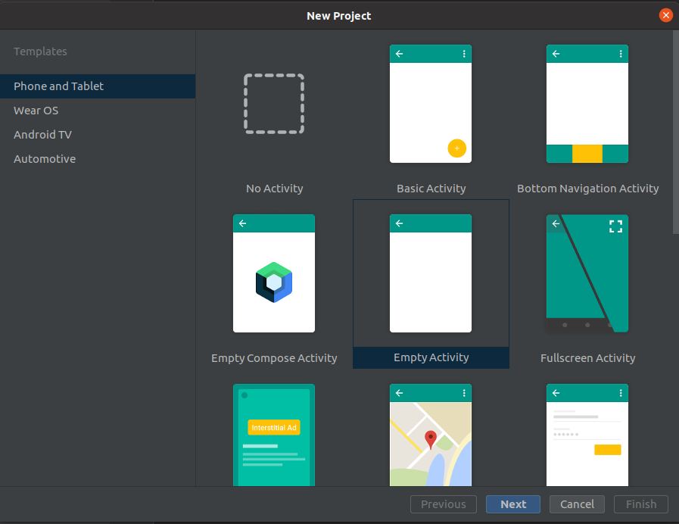

2.Добавить поле EditText тип textMultiLine

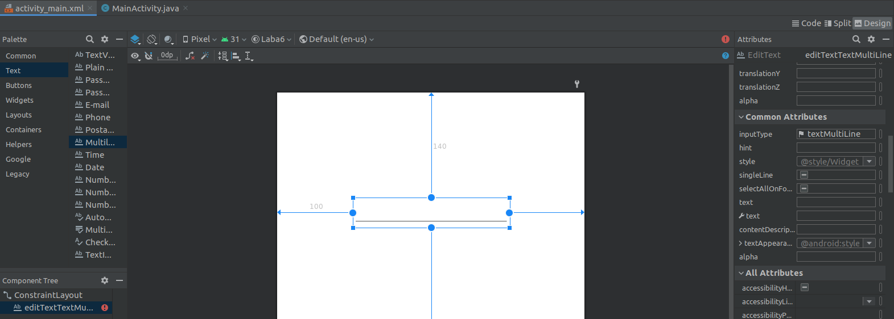

3. Добавить 2 кнопки – Получить данные и сохранить данные и

создать для них обработчики событий

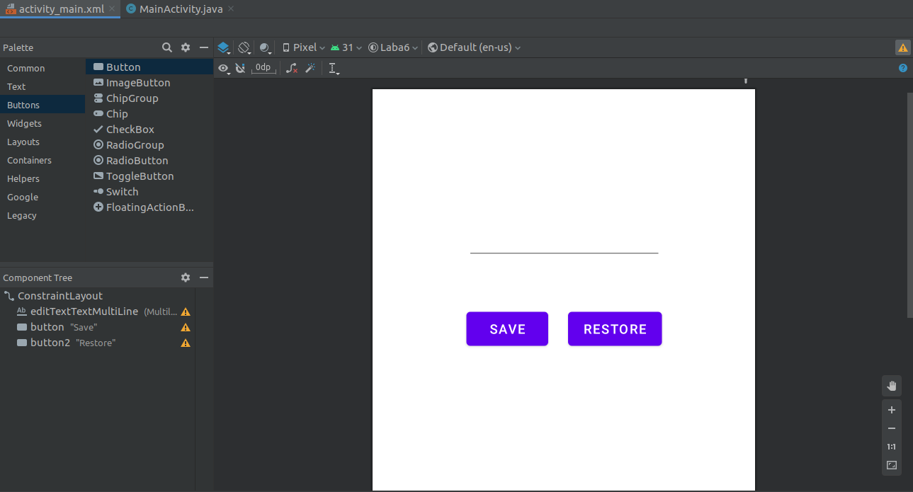

4. public void restoreField(View view)

{

TextView nameView = (TextView) findViewById(R.id.saveTextView);

nameView.setText(name);

}

5. public void saveField(View view)

{

TextView nameBox = (TextView)

findViewById(R.id.editTextTextMultiLine);

name = nameBox.getText().toString();

}

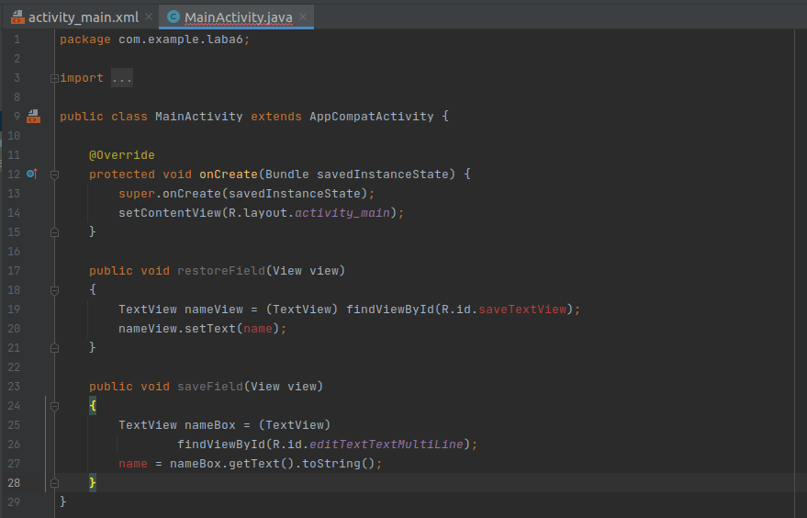

6. Добавить поле TextView

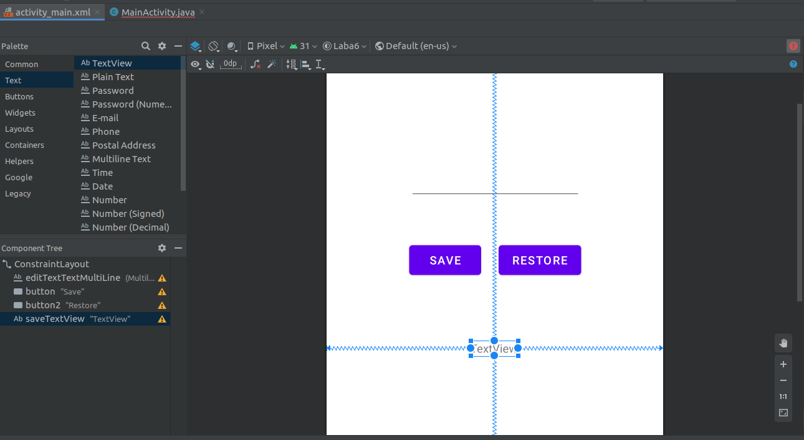

7. Добавим в них код

8. public class MainActivity extends AppCompatActivity

{

String name =&quot;неопределено&quot;;

final static String nameVariableKey = &quot;NAME_VAR&quot;;

final static String textViewTexKey = &quot;TEXT_VIEW&quot;;

@Override

protected void onCreate(Bundle savedInstanceState)

{

super.onCreate(savedInstanceState);

setContentView(R.layout.activity_main);

}

@Override

protected void onSaveInstanceState(Bundle outState)

{

outState.putString(nameVariableKey, name);

TextView nameView = (TextView) findViewById(R.id.saveTextView);

outState.putString(textViewTexKey,

nameView.getText().toString());

super.onSaveInstanceState(outState);

}

@Override

protected void onRestoreInstanceState(Bundle savedInstanceState)

{

super.onRestoreInstanceState(savedInstanceState);

name = savedInstanceState.getString(nameVariableKey);

String textViewText=

savedInstanceState.getString(textViewTexKey);

TextView nameView = (TextView) findViewById(R.id.saveTextView);

nameView.setText(textViewText);

}

}

Итог:

package com.example.laba6;

import androidx.appcompat.app.AppCompatActivity;

import android.os.Bundle;

import android.view.View;

import android.widget.TextView;

public class MainActivity extends AppCompatActivity {

String name ="неопределено";

final static String nameVariableKey = "NAME_VAR";

final static String textViewTexKey = "TEXT_VIEW";

@Override

protected void onCreate(Bundle savedInstanceState) {

super.onCreate(savedInstanceState);

setContentView(R.layout.activity_main);

}

public void restoreField(View view)

{

TextView nameView = (TextView) findViewById(R.id.saveTextView);

nameView.setText(name);

}

public void saveField(View view)

{

TextView nameBox = (TextView)

findViewById(R.id.editTextTextMultiLine);

name = nameBox.getText().toString();

}

@Override

protected void onSaveInstanceState(Bundle outState)

{

outState.putString(nameVariableKey, name);

TextView nameView = (TextView) findViewById(R.id.saveTextView);

outState.putString(textViewTexKey,

nameView.getText().toString());

super.onSaveInstanceState(outState);

}

@Override

protected void onRestoreInstanceState(Bundle savedInstanceState)

{

super.onRestoreInstanceState(savedInstanceState);

name = savedInstanceState.getString(nameVariableKey);

String textViewText=

savedInstanceState.getString(textViewTexKey);

TextView nameView = (TextView) findViewById(R.id.saveTextView);

nameView.setText(textViewText);

}

}

Итог:

